Exercise 1- OOP

|  |
| --- |
| Class : Cat |
| Breed: string  Color: string  Body type: string  Character: string |
| eat() : void  sleep() : void  walk() : void  jump() : void  sit() : void  climb() : void  run() : void |



|  |
| --- |
| Class: Dog |
| Breed: string  Color: string  Body type: string  Character: string |
| eat() : void  sleep() : void  walk() : void  jump() : void  sit() : void  climb() : void  run() : void |

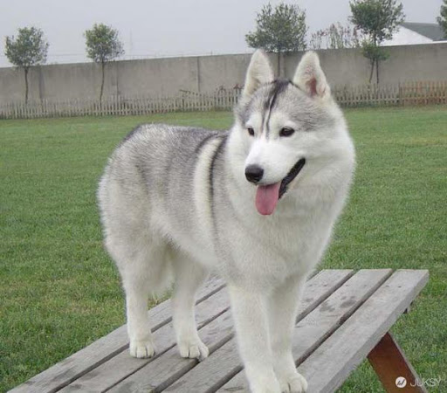

|  |
| --- |
| Class: Person |
| Name: string  Age: num  Gender: string |
| eat() : void  sleep() : void  work() : void  walk() : void  sit() : void  study() : void |



|  |
| --- |
| Class: Cell phone |
| Brand: string  Color: string  Model: string |
| call() : void  listenMusic() : void  sendMessage() : void  receiveMessage() : void  playGame() : void  changeVolume() : void |



|  |
| --- |
| Class: Laptop |
| Brand: string  Color: string  Model: string |
| watchMovie() : void  playGame() : void  listenMusic() : void  typing() : void  changeVolume() : void |

